Ref. Error! Unknown document property name.

31/05/2023

Key Conclusions (by Copa and Cogeca)
Assessment of the impacts of phasing out cages in the EU pig and laying hen sectors
Context and methodology
Following the Communication of the European Commission on the ECI “End the Cage Age” in June 2021, Copa and Cogeca commissioned an impact assessment from the Institute of Agricultural Economics Nonprofit Kft. (AKI, Budapest, Hungary), the Foundation Science and Education for Agri-Food Sector (FNEA, Warsaw, Poland) and the European Centre for Agricultural, Regional and Environmental Policy Research (EuroCARE GmbH, Bonn, Germany) to better understand the socioeconomic and environmental consequences of the ban of cages on the pig and laying hen sectors (meat and eggs) based on the elements reflected in the Commission’s Communication. The impact assessment, drawing on extensive literature reviews, was conducted according to a two-pronged approach:
(1) farm-level analyses based on farm-level surveys and expert consultations in selected EU Member States, with an attempt to scale up the results to sector levels;
(2) sectoral analyses conducted within individual EU Member States and for the EU as a whole with the use of the Common Agricultural Policy Regional Impact (CAPRI) model.
The CAPRI model was used to assess the impacts of the ban on farrowing crates for sows and enriched cages for laying hens on supply balances and prices, producer incomes and selected macroeconomic and environmental indicators in all EU27 regions (NUTS2 level).
This model was used to compare three main scenarios for the transition:
- an immediate transition by 2025 (Scenario A)
- a transition by 2035 (Scenario B1 and B2)
- a transition by 2045 (Scenario C1 and C2)
As with any modelling, the results of this study need to be considered carefully, the key being to understand the broad trends and effects on a continental scale and further afield while considering trade policy aspects.
Impact of the ban on farrowing crates on EU27 pig farm production

Pig production will be the most impacted sector according to the study. In all scenarios, the ban on farrowing crates would result in (1) significant investment, (2) deteriorating production efficiency (3) and, as the model results show, a reduction in the EU27 sow population and piglet production.
Production declines by 23.6% against the CAPRI baseline when farmers are required to transition immediately (Scenario A). Extending the transition deadline by 10 years (Scenarios B) or by 20 years (Scenarios C) significantly slows down this negative development, resulting in a decline of between 8.4-0.5%. Transitioning to free farrowing systems will require significant investment in new pens and in reconstructing existing buildings. Depending on what farmers decide, investment costs may range from around EUR 2.1 to 3.5 billion (based on 2021 prices) across the different scenarios.
Impact of the ban on enriched cages on EU27 egg farm production
The ban on enriched cages will require significant investment in the egg sector too, potentially resulting in reduced EU egg production. The laying hen flock is estimated to fall within the range of 330 million to 379 million after the full transition. Before the transition is complete, egg production is likely to go on a downward trajectory due to the decline in the number of laying hens. Production will also be influenced by a slight expected reduction in egg yields per laying hen.
The total value of the necessary investments, expressed similarly in 2021 prices, will also depend on whether farmers decide to abandon or continue with production in future. The EU-27 is expected to require investments totalling at least EUR 3.2 billion.
Overall impact on EU27

- A severe impact on the EU27 net trade balance in all scenarios – The drop in production in the pig sector and to a lesser extent in poultry has an impact on the EU's trade balance: In most cases, domestic market demand does not decrease in proportion to the drop in production, leading to a very strong increase in imports, particularly of pork in all scenarios (between 1086% and 43.7%), but also of eggs (between 18% and 5%). Conversely, EU27 exports decrease sharply for pork and eggs. In all three scenarios, the EU27 trade balance will be in a deficit across these key types of livestock production by 2045.
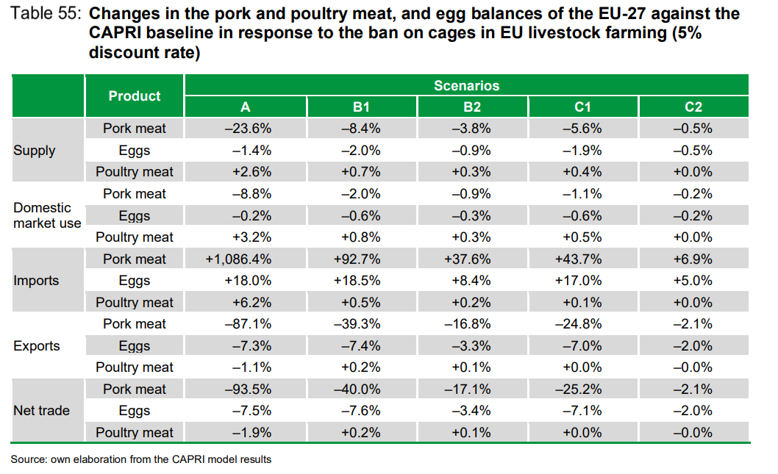
- Producer/consumer price is highly dependent on the transition period chosen -In Scenario A, the average producer price for pork surges by 47.4% in the EU-27 compared to a 3.7% increase for eggs. When a 10-year or 20-year long transition period is granted, the rise in the producer price for pork becomes much smaller and leads to more moderate shocks for consumers. Changes in producer and consumer prices for eggs are less significant in all scenarios (between 3.8% and 0.3%). It should be noted that both producer and consumer prices for pork and eggs exhibit a larger increase in the EU-East.

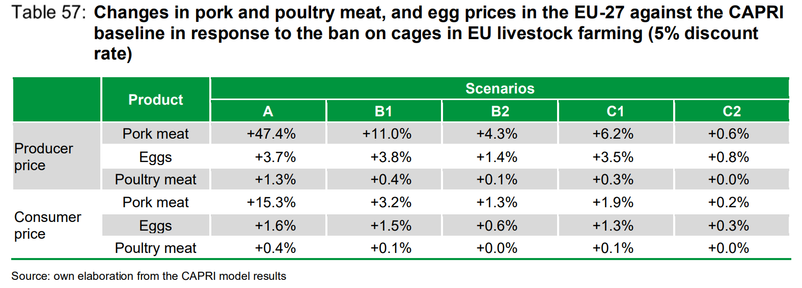

- Different impacts on farm profits depending on production – Profits in the EU-27 pig sector shrink by a considerable 37.8% against the CAPRI baseline in Scenario A, explaining the sizeable decline in pork production in the extreme situation where no transition period is provided for. In the egg sector, the impacts are expected to be less severe with profits diminishing by 0.9% in Scenario A because of the substantial advancement in transitioning to cage-free housing systems. The estimated impact on profits in the pig sector appear to gradually erode over time. Taking a closer look at the EU macro-regions, the profit loss in the pig sector is markedly higher in the EU-West (41.5%) compared to the EU-East (21.6%) in Scenario A. However, this position appears to reverse over time.

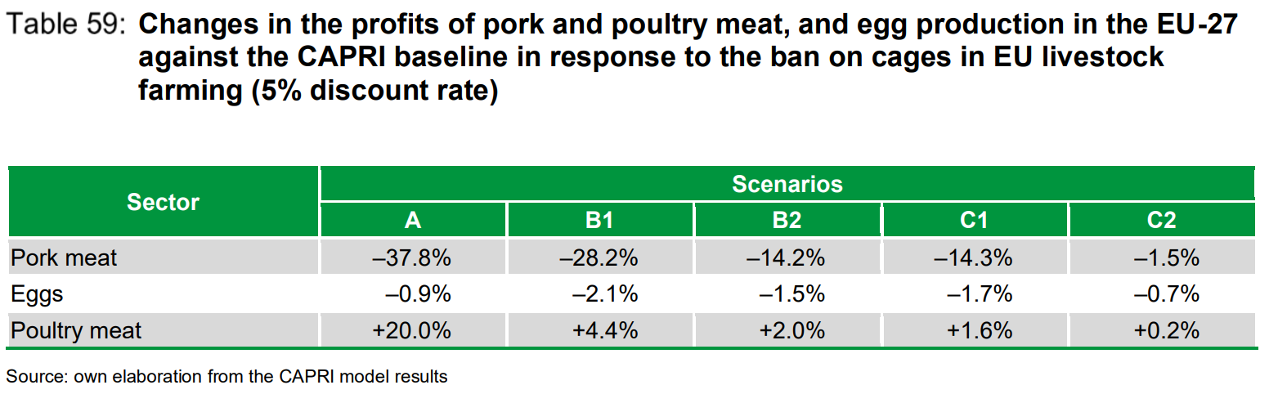

- A real challenge for the integrity of the EU27 internal market - A comparison of pig farming across the EU macro-regions (EU-14 and EU-13) provides important indications regarding the scenario outcomes. Regardless of the length of the transition period, the new policy appears to have a lasting dividing effect on the economic performance of the EU-West (EU-14) and EU-East (EU-13) livestock sectors. Irrespective of the length of the transition period, the percentage decline in pork supply is considerably higher in the EU-East compared to the EU-West. The same conclusion applies to eggs to a smaller extent.

Changes in production at the NUTS-2 level of individual EU Member States against the CAPRI baseline in response to the ban on cages, with different discount rates – Most likely scenario with a transition by 2035
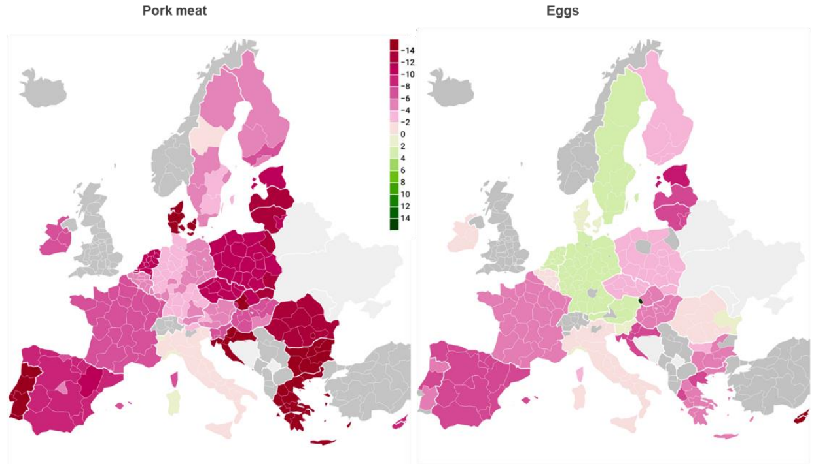

- Concentration of pig and egg farms - The process of piglet production concentration is also expected to intensify due to some small-scale producers possibly leaving the profession while others switch, exclusively, to finishing. It is expected that the ban on enriched cages will also exacerbate EU egg sector concentration. The progress which has been achieved in transitioning to alternative housing systems before any introduction of a ban by the European Commission suggests this process would continue without such an intervention, albeit at a slower pace.
- Little impact on the global warming potential (GWP) due to carbon leakage - The commissioned impact assessment also includes a section on the environmental impact of excluding cages. The study looks at the impact on emissions at EU level but also at the effects related to the impacts on international trade. A switch to alternative housing systems in the EU-27 would be counterintuitive. Not only would it reduce production, it would also result in unintended environmental impacts and lowered physical performance of sows and laying hens. In most scenarios, the decrease in global warming potential in Europe is offset by its increase in third countries, leading more or less to a zero-sum game in scenarios B and C.
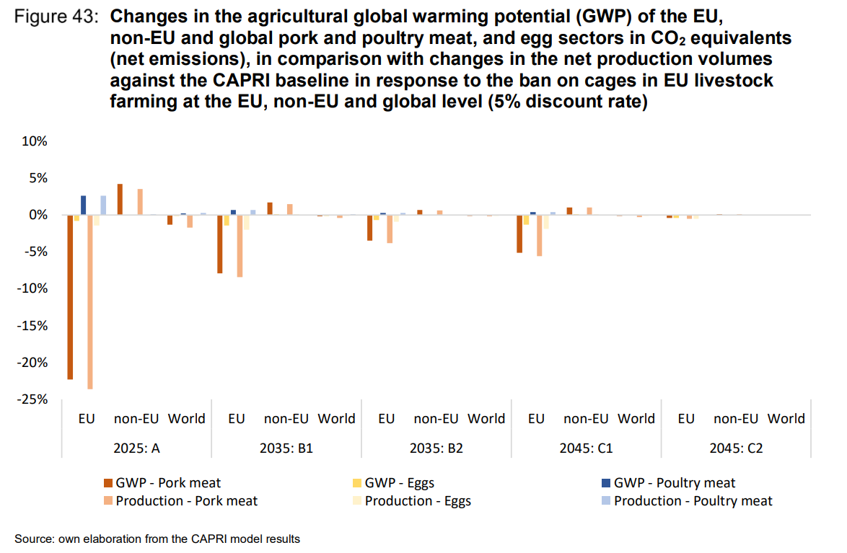

-END-
Translations will be available in DE, ES, FR, IT, PL and RO on the Copa-Cogeca website soon.
About us - Copa and Cogeca are the united voice of farmers and agri-cooperatives in the EU. Together, we ensure that EU agriculture is sustainable, innovative and competitive, while guaranteeing food security for 500 million people throughout Europe. >>> More information www.copa-cogeca.eu

For further information, please contact
Manon Dubois  Policy Advisor  manon.dubois@copa-cogeca.eu | Jean-Baptiste Boucher  Communication Director  +32 474 84 08 36  jean-baptiste.boucher@copa-cogeca.eu

