Ref. COMM(23)05484

30/11/2023

Press Release
Cogeca elects new President, Lennart Nilsson
The European agri-cooperatives organisation, Cogeca, held an election today in Brussels. Lennart Nilsson from the Swedish organisation LRF was appointed to lead the organisation representing over 22,000 farming cooperatives across the EU. Lennart Nilsson will replace the outgoing Spanish President, Ramon Armengol (Cooperativas Agro-alimentarias) after 4 years of presidency as of January.
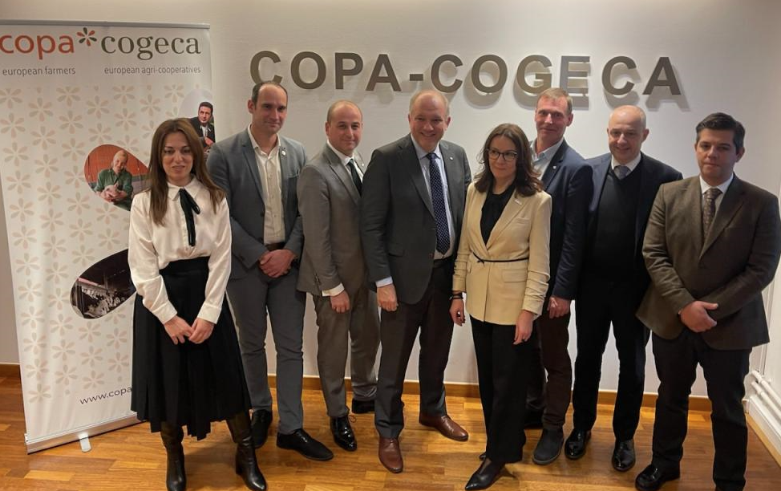
All European organisations representing the farming cooperative movement met today in Brussels to elect a new presidency for 2024-2026. Cogeca members opted for experience in electing Lennart Nilsson, a Swedish farmer, and member of the LRF board, who has been actively involved in his cooperative (Lantmännen) at national level and in Copa and Cogeca’s working parties for several years.
After his election, Lennart Nilsson declared, "I'm well aware of the responsibility I'll have to shoulder in the months ahead. The obstacles we've had to face in recent years have been numerous, from the consequences of the COVID crisis, to the war in Ukraine, to galloping inflation. I would like to thank Ramon Armengol for the way he has led our organisation through these difficult times. I intend to continue his work, particularly involving young farmers in the cooperative movement all across the EU."
In a video message recorded after his election and broadcast on Copa-Cogeca's platforms, Lennart Nilsson added, "We have a lot of challenges for the future. We hope that we farmers and cooperatives can be part of the discussion at EU level concerning the solutions. We have several possibilities to provide the EU with good, safe food, but also energy and biomass. Cooperatives will play a key role in the green transitions."
Mr. Nilsson will be supported by the following six Vice-Presidents, who were also elected today: Agnieszka Maliszewska (Federacja Branżowych Związków Producentów Rolnych, Poland), Leonardo Pofferi (Alleanza delle Cooperative Italiane, Italy), Florentin Bercu (Alliance for Agriculture and Cooperation, Romania), Mickael Marcerou (La Coopération Agricole, France), Christian Høegh-Andersen (Landbrug & Fødevarer, Denmark) and Idalino Leão (Confederacão Nacional das Cooperativas Agrícolas e do Crédito Agrícola de Portugal, Portugal).

-END-
Translations will be available in DE, ES, FR, IT, PL and RO on the Copa-Cogeca website soon.
About us - Copa and Cogeca are the united voice of farmers and agri-cooperatives in the EU. Together, we ensure that EU agriculture is sustainable, innovative and competitive, while guaranteeing food security for 500 million people throughout Europe. >>> More information www.copa-cogeca.eu

For further information, please contact
Umberto Di Pasquo  Director Cooperative Affairs and Administration  umberto.dipasquao@copa-cogeca.eu | Jean-Baptiste Boucher  Communication Director  +32 474 84 08 36  jean-baptiste.boucher@copa-cogeca.eu

Press Release Mailing List
Unsubscribe
Subscribe

