Ref.COMM(25)02521 rev1
02/10/2025

Joint Press Release
Agricultural leaders from both sides of the Atlantic convene to address global challenges
Leaders from Copa-Cogeca (EU farmers and agri-cooperatives), the American Farm Bureau Federation (AFBF), the Canadian Federation of Agriculture (CFA), and the Mexican National Agricultural Council (CNA) gathered these past days in Lake Como, Italy, for the 41st edition of the North America – EU Agricultural Conference. The Conference was hosted by the main Italian agricultural organisations: Confagricoltura, CIA Agricoltori Italiani, Coldiretti and the Alliance of Italian agricultural cooperatives.
This long-standing forum brought together farm leaders from across the Atlantic to exchange views, strengthen cooperation, and reflect on shared opportunities and challenges facing the agricultural sector.
Discussions focused on production challenges and food security, particularly the need to secure reliable supply chains in an increasingly uncertain global environment. Participants also addressed sustainability, underlining the dual objective of reducing agriculture’s environmental footprint while strengthening farmers’ ability to adapt to extreme weather events and enhance efficiency and productivity. Innovation and competitiveness were another central theme, with exchanges exploring how new technologies and trade opportunities can sustain viable farm businesses and vibrant rural communities. The importance of rules-based trade was reaffirmed, emphasising transparent, science-based standards and the open exchange of goods and knowledge between partners. Finally, the debate highlighted the resilience of the sector, examining which policies can best support farm enterprises and promote generational renewal.
Participants highlighted the enduring value of transatlantic cooperation and reiterated their commitment to continued dialogue and collaboration between farmers’ organisations in Europe and North America.
The Conference once again demonstrated that, while farming systems and contexts may differ, producers on the two sides of the Atlantic share a common purpose: to provide safe, sustainable, and affordable food for citizens, while contributing to vibrant rural areas and a resilient global food system.
The four organisations look forward to continuing this dialogue at the 42nd edition of the North America – EU Agricultural Conference, which will be hosted in Mexico in 2027.
-END-
Note: High-resolution images are available below and may be used freely for press purposes.
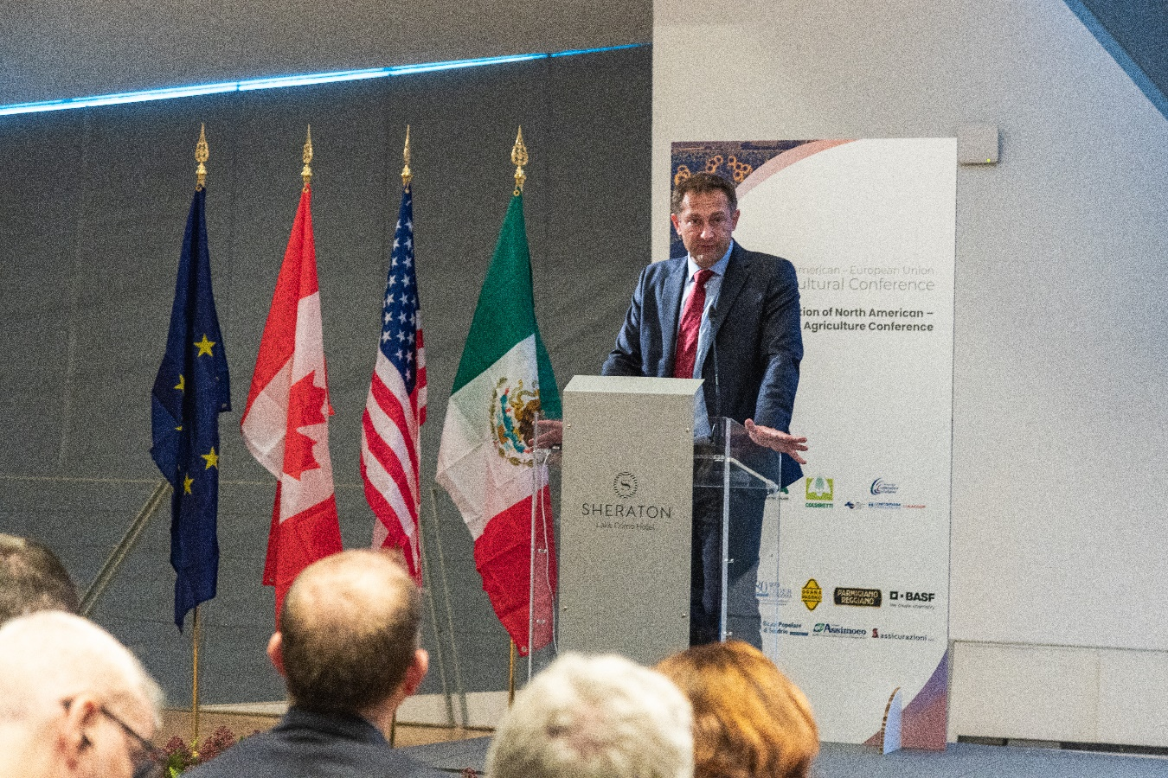
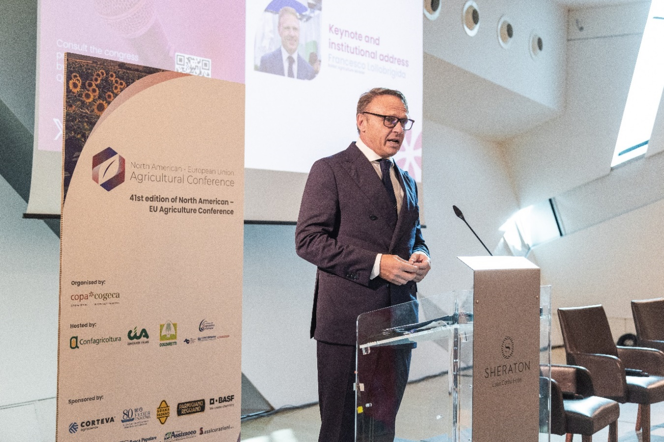
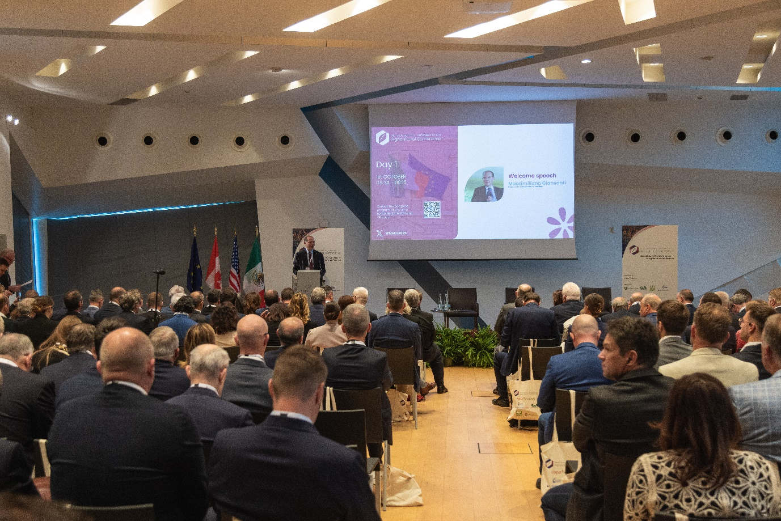
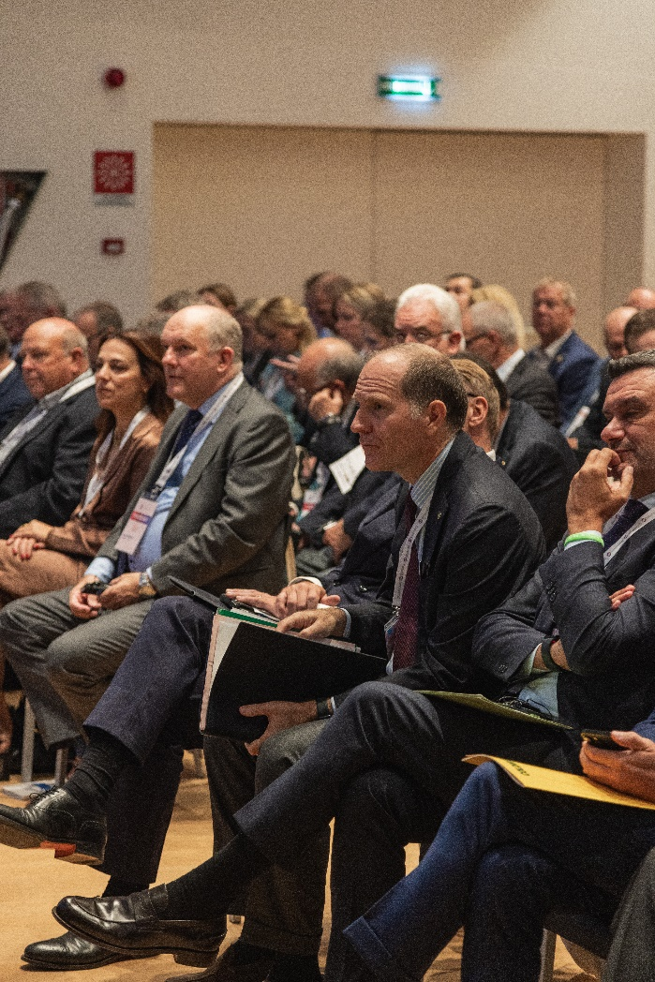

For further information, please contact
Ksenija Simovic
Senior Policy Advisor
ksenija.simovic@copa-cogeca.eu

Press Release Mailing List
Unsubscribe
Subscribe

