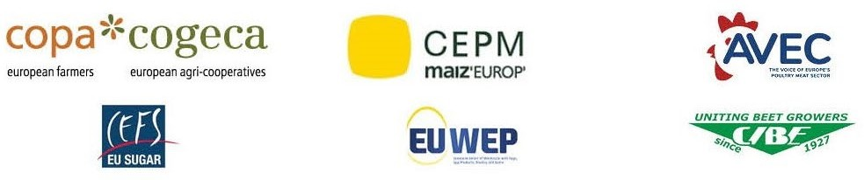

COMM(24)00567

22/02/2024

Joint Press Release

The Council has chosen to ignore farmers' concerns regarding Ukraine ATMs; it is now imperative for the European Parliament to take action

**Despite demonstrations and factual evidence, the Council’s Coreper II, the permanent representatives committee, took the decision yesterday not to improve further the Commission proposed text on Ukraine ATMs. Should the text remain unamended also by the European Parliament, the economic sustainability of the EU's poultry meat, eggs, sugar, grain, and honey sectors will be endangered.**

While there is an understanding of the political sensitivity that misguided the decision at Council level, as well as the need to support Ukraine, it is unfortunate that the small adjustments which would have delivered an effective solution for European producers while maintaining EU citizens support to Ukraine were not considered.

With the protest movements intensifying in Ukraine's neighboring countries, and with the increasing effects of these imports registered in other Member States, it is a justified fear that unilateral actions will continue, putting in danger the integrity of the Single market and so far, unwavering support to the Ukrainian cause in a significant part of the population.

Without a more strategic outlook, Europe faces a double setback: on the one hand, disruptions to the domestic market which are most likely set to intensify, while on the other, Ukraine’s traditional markets being replaced by Russian cereals and products.

The decisions made by the Commission and the Council, as well as the limited time granted to them for deliberation, should not discourage the Members of the European Parliament to, over the next days and weeks, ask for the proposal to be further amended. Showing in their positions the understanding for the situation on the ground and the necessary solutions for affected farmers.

The European farming community is ready to carry its part of the burden, but it expects not to be left alone in carrying most of it. We call on the MEPs to ensure clear and effective measures are taken for all the sectors affected.

On behalf of the following associations:

**AVEC –** Association of Poultry Processors and Poultry Trade in the EU countries

**CEFS –** European Association of Sugar Manufacturers

**CEPM –** European Confederation of Maize Production

**CIBE –** International Confederation of European Beet Growers

**COPA-COGECA -** The united voice of farmers and their cooperatives in the European Union

**EUWEP -** European Union of Wholesale with Eggs, Egg Products, Poultry and Game

**-END-**

Translations will be available in DE, ES, FR, IT, PL and RO on the Copa-Cogeca website soon.

For further information, please contact:

**Birthe Steenberg** - Secretary General AVEC׀ELPHA׀EPB +32 492 10 75 71 [bs@avec-](mailto:bs@avec-poultry.eu) [poultry.eu](mailto:bs@avec-poultry.eu)

**Judith Schrenk** - Communications & Social Affairs Manager CEFS +32 2 774 51 07 [judith.schrenk@cefs.org](mailto:judith.schrenk@cefs.org)

**Arthur Boy** - Policy Advisor for economic affairs CEPM [arthur.boy@agpm.com](mailto:arthur.boy@agpm.com) +33 6 79 05 78 31

**Elisabeth Lacoste** – Director CIBE +32 2 50 46 091 [elisabeth.lacoste@cibe-europe.eu](mailto:elisabeth.lacoste@cibe-europe.eu)

**Ksenija Simovic** - Senior Policy Advisor COPA-COGECA +32 473 66 30 71 [ksenija.simovic@copa-cogeca.eu](mailto:ksenija.simovic@copa-cogeca.eu)

**Bruno Menne** - Director of Commodities COPA-COGECA +32 478 18 99 09 [bruno.menne@copa-cogeca.eu](mailto:bruno.menne@copa-cogeca.eu)

**Clara Hagen** - Secretary General EUWEP +31 30 637 8844 [Clara.Hagen@euwep.org](mailto:Clara.Hagen@euwep.org)