LETTER(25)01098:1 – PPA/jg Brussels, 16 April 2025

Open letter to Commission President von der Leyen
A historic misstep? Undermining the architecture of Europe’s first common policy — the CAP — will inevitably weaken Europe's security.
Dear President von der Leyen,
In an era of geopolitical instability, economic uncertainty, and mounting societal challenges, a strong and resilient agricultural sector is not just strategic; it is the keystone that supports the EU’s entire security architecture. Copa-Cogeca and its members representing European farmers and agri-cooperatives are steadfast in our commitment to ensuring food security, sustainability, as well as economic and social stability for 450 million citizens of Europe and beyond.
The pan-European agricultural protests of 2024, though driven by different causes, all revealed the vulnerability of our communities, exposed to the cumulative and conflicting effects of policies in an increasingly complex market environment.
The recent European Commission’s Vision for EU Agriculture and Food rightly acknowledges the sector’s strategic importance. Likewise, the Council’s EU Strategic Agenda and the Commission’s political guidelines for the 2024-2029 mandate recognise the indispensable contribution of farmers and rural communities to Europe’s economic and social fabric.
The farming community is still grappling with numerous challenges, such as geopolitical instability, high energy prices, legal uncertainties, and stricter environmental regulations. While farmers have made significant progress in improving productivity and reducing emissions, they still face rising costs and unfair competition, which is eroding their income and making it harder to remain competitive.
As you, President von der Leyen, rightly emphasised: we are entering a new era of rearmament in which Europe must assume greater responsibility for its own security. In this spirit, we firmly believe that there is no security without food security — and no strategic autonomy without food autonomy.
This is why we are profoundly alarmed by recent discussions on reallocating EU funding into a Single Fund effectively eliminating the EAGF and EAFRD – the pillars of the Common Agricultural Policy (CAP). Such a shift represents a fundamental change to the governance of the next Multiannual Financial Framework (MFF) and would severely undermine the CAP, which remains the cornerstone of Europe’s competitiveness and food sovereignty.
Dismantling the two-pillar CAP structure based on the EAGF and EAFRD alongside using a single national programming approach per Member State will lead to a further loss of commonality in European policies. Besides further weakening the Single Market, this will have far-reaching consequences for food production and security and the maintenance of vibrant and populated rural areas in the EU. There is a clear added value in European expenditure when it comes to policies such as the CAP and this must be recognised and kept.
We are not the only ones who think so. Alongside 28 other key EU agri-food organisations, we have already conveyed a simple but crucial message to you and EU leadership: a dedicated increased CAP budget is not merely a matter of financial support, but a strategic investment in Europe’s future resilience and security.
It was also one of the key conclusions of the Strategic Dialogue that were delivered to you last September: the multiple transitions required for European agriculture can and will only be achieved if they are properly financed.
As the European Commission prepares to present the next MFF, expected for July 2025, we call on you, President von der Leyen, to effectively prioritise agriculture as a fundamental pillar of Europe’s future by turning your words into concrete actions.
We also urge the Commission to include an automatic flexible and rapid response mechanism within the MFF to adjust the financial allocations in real time based on actual observed inflation rates instead of the projected ones.
Always faithful to the spirit of the EU's founders, initiators of the Union's first common policy, we are, today, calling for the preservation of the unity and strength that bind our agricultural communities and, with it, the entire EU.
To thrive, our communities need more than promises! We need stability, predictability, trust and legal certainty.
We respectfully request a meeting with you to continue the dialogue which took place in the context of the 2024 protests. As the window of opportunity narrows, we firmly believe that this is still a time for dialogue, not disengagement.
Thank you for your highest attention.
Yours sincerely,
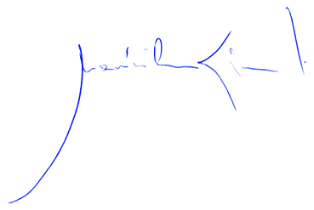 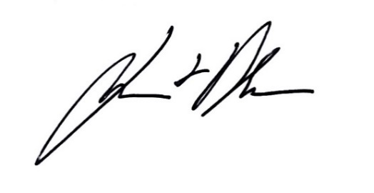Massimiliano Giansanti Lennart Nilsson
Copa President Cogeca President

